

#### Image Processing

**Student:** Yasser Mahmoud Abd Elghany

##### Under Supervision of

**Dr. Dr Mohamed Abd Elfattah**

Lecturer at Department of Computer Science

Misr Higher Institute for Commerce and Computers in Mansoura

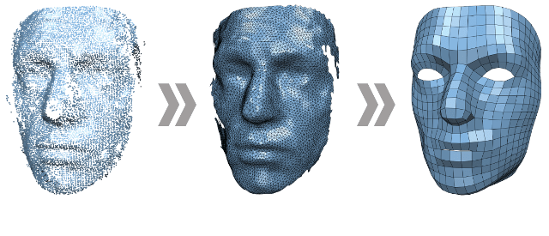

What is Image processing?

Image processing is a method to perform some operations on an image, in order to get an enhanced image or to extract some useful information from it. It is a type of signal processing in which input is an image and output may be image or characteristics/features associated with that image. Nowadays, image processing is among rapidly growing technologies. It forms core research area within engineering and computer science disciplines too.

Image processing basically includes the following three steps:

* Importing the image via image acquisition tools;
* Analysing and manipulating the image;
* Output in which result can be altered image or report that is based on image analysis.

There are two types of methods used for image processing namely, analogue and digital image processing. Analogue image processing can be used for the hard copies like printouts and photographs. Image analysts use various fundamentals of interpretation while using these visual techniques. Digital image processing techniques help in manipulation of the digital images by using computers. The three general phases that all types of data have to undergo while using digital technique are pre-processing, enhancement, and display, information extraction.

Why is Image Processing Required?

Image processing is often viewed as arbitrarily manipulating an image to achieve an aesthetic standard or to support a preferred reality. However, image processing is more accurately defined as a means of translation between the human visual system and digital imaging devices. The human visual system does not perceive the world in the same manner as digital detectors, with display devices imposing additional noise and bandwidth restrictions. Salient differences between the human and digital detectors will be shown, along with some basic processing steps for achieving translation. Image processing must be approached in a manner consistent with the scientific method so that others may reproduce, and validate, one's results. This includes recording and reporting processing actions, and applying similar treatments to adequate control images.

Image Processing serves the following main purpose:

* Visualization of the hidden objects in the image.
* Enhancement of the image through sharpening and restoration.
* Seek valuable information from the images.
* Measuring different patterns of objects in the image.
* Distinguishing different objects in the image.

Applications of Digital Image Processing

Some of the major fields in which digital image processing is widely used are mentioned below

* Image sharpening and restoration
* Medical field
* Remote sensing
* Transmission and encoding
* Machine/Robot vision
* Color processing
* Pattern recognition
* Video processing
* Microscopic Imaging
* Others

## Image sharpening and restoration

Image sharpening and restoration refers here to process images that have been captured from the modern camera to make them a better image or to manipulate those images in way to achieve desired result. It refers to do what Photoshop usually does.

This includes Zooming, blurring , sharpening , gray scale to color conversion, detecting edges and vice versa , Image retrieval and Image recognition. The common examples are:

The original image

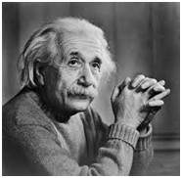

The zoomed image

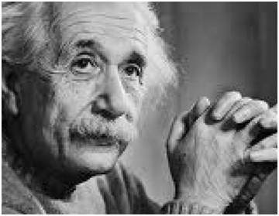

Blurr image

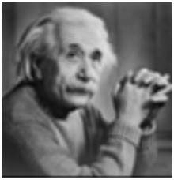

Sharp image

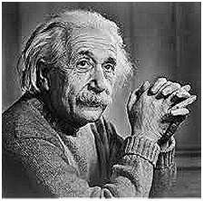

Edges

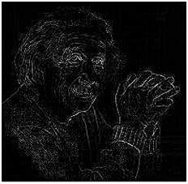

## Medical field

The common applications of DIP in the field of medical is

* Gamma ray imaging
* PET scan
* X Ray Imaging
* Medical CT
* UV imaging

## UV imaging

In the field of remote sensing , the area of the earth is scanned by a satellite or from a very high ground and then it is analyzed to obtain information about it. One particular application of digital image processing in the field of remote sensing is to detect infrastructure damages caused by an earthquake.

As it takes longer time to grasp damage, even if serious damages are focused on. Since the area effected by the earthquake is sometimes so wide , that it not possible to examine it with human eye in order to estimate damages. Even if it is , then it is very hectic and time consuming procedure. So a solution to this is found in digital image processing. An image of the effected area is captured from the above ground and then it is analyzed to detect the various types of damage done by the earthquake.

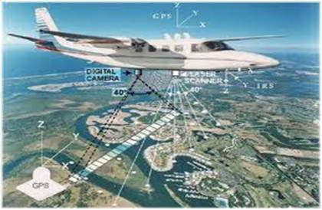

The key steps include in the analysis are

* The extraction of edges
* Analysis and enhancement of various types of edges

## Transmission and encoding

The very first image that has been transmitted over the wire was from London to New York via a submarine cable. The picture that was sent is shown below.

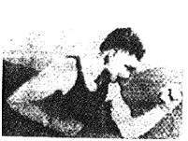

The picture that was sent took three hours to reach from one place to another.

Now just imagine , that today we are able to see live video feed , or live cctv footage from one continent to another with just a delay of seconds. It means that a lot of work has been done in this field too. This field doesnot only focus on transmission , but also on encoding. Many different formats have been developed for high or low bandwith to encode photos and then stream it over the internet or e.t.c.

## Machine/Robot vision

Apart form the many challenges that a robot face today , one of the biggest challenge still is to increase the vision of the robot. Make robot able to see things , identify them , identify the hurdles e.t.c. Much work has been contributed by this field and a complete other field of computer vision has been introduced to work on it.

## Hurdle detection

Hurdle detection is one of the common task that has been done through image processing, by identifying different type of objects in the image and then calculating the distance between robot and hurdles.

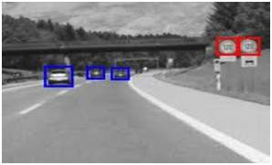

## Line follower robot

Most of the robots today work by following the line and thus are called line follower robots. This help a robot to move on its path and perform some tasks. This has also been achieved through image processing.

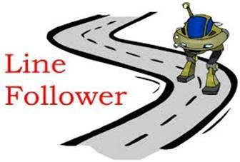

## Color processing

Color processing includes processing of colored images and different color spaces that are used. For example RGB color model , YCbCr, HSV. It also involves studying transmission , storage , and encoding of these color images.

## Pattern recognition

Pattern recognition involves study from image processing and from various other fields that includes machine learning (a branch of artificial intelligence). In pattern recognition , image processing is used for identifying the objects in an image and then machine learning is used to train the system for the change in pattern. Pattern recognition is used in computer aided diagnosis , recognition of handwriting , recognition of images.

## Video processing

A video is nothing but just the very fast movement of pictures. The quality of the video depends on the number of frames/pictures per minute and the quality of each frame being used. Video processing involves noise reduction , detail enhancement , motion detection , frame rate conversion , aspect ratio conversion , color space conversion.